**TIBCO Spotfire Development – Best Practices**

Below are some recommended best practices that should be followed during development process for TIBCO Spotfire:-

1. **Naming Convention:-** Proper naming convention should be followed in order to avoid confusion:-
2. **Datasources/Data connection**:- All Spotfire data sources should be names like:

“DB Type_Project name_DBname _Dev/QA/Prod”

Ex: - MSSQL_Verisk_testDB_QA

1. **Information link:-** It should have IL as prefix, data table name and project name

“IL_Data table name_project name”

Ex:- IL_Employees_Verisk

1. **Column Name: -** It should be as per the Business requirement.
2. **Joins:**- Join should contain name of both ILs involved:-

Join_IL1_IL2

1. **Procedure:-** For stored procedures naming should be like :-

“Proc_Projectname_DBname_procedureDBname”

Ex: - Proc_Verisk_TestDB_TestSP

ProcedureDBname is the name of stored procedure as in database.

1. **DXP:-** Reports are generally named as per end user requirement. If there are no specific requirements, make sure to mention Project name and report’s brief application in the DXP name.
2. **Setting up Folder structure: -** Following folder structure is recommended for implementation during project development.

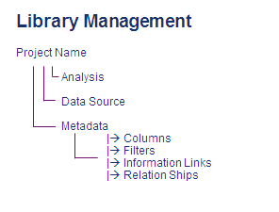

In case a project has multiple sub-projects, each subproject should have a folder structure as above.

1. **Analysis: -** This folder should have all he Dxp’s files. Can also have personalized sub-folders in case somebody is working on a DXP and wants to keep it apart from other files.
2. **Datasource: -** All datasource/data connection related to project should be kept here. This folder should have restricted privileges.
3. **Metadata: -** Information links, joins, columns, procedures filters are to be kept here.
4. **Library security and licensing:-** There are two major security areas in Spotfire:-
5. **Library security: -** Accomplished by creating groups in Administration manager and giving privileges to these groups on Library folders. It helps in restricting people to a specific project folder. For example:-

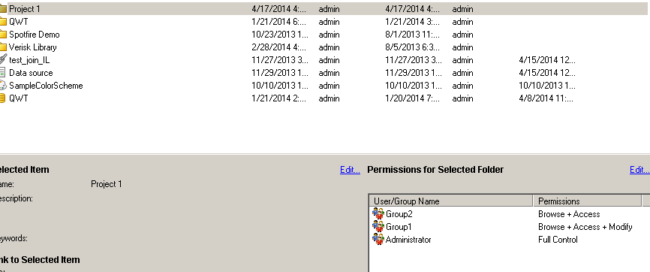

We created two groups for Project 1, Group 1 can be developers who will have red write access and Group2 can be end users with read only access. Administrator should have full control on all folders.

1. **Licensing: -** Licensing is used to restrict users based on Spotfire features available to them. We can create multiple groups as mentioned below:-

-Professional user

-Webplayer user

-Professional + Script author

-Professional + Extensions

As per project requirement we can segregate user access based on these groups. The licenses can be assigned to each group through Administration Manager:-

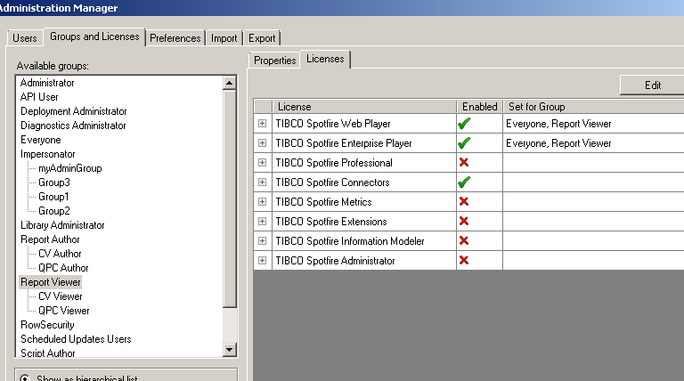

1. **Information link customization**

Changing the SQL on Information Link level is not recommended. Even if it is required to edit the SQL, we should not:-

* alter the name of a column (the AS-part of SELECT xxx AS yyy)
* alter the number of columns returned
* alter the data type of columns returned
* alter the order of columns returned
* remove <temporary_result_#> from the FROM-clause in information links that go against multiple data sources
* remove the trailing WHERE <conditions>, as it will be replaced by any conditions applied at runtime

1. **Use sample Dxp as template (Cover page/index page)**

The Cover page should contain a brief description for all the tabs in the report. A hyperlink should be provided, so that customer can navigate directly to the concerned tab without going through all the tabs.

A sample DXP can be placed in Spotfire library and should be used throughout the project to create reports.

1. **Deciding best visualizations for data**

Spotfire contains a variety of visualization types and it’s very essential to decide what visualizations are best suited to represent your data. Make sure to go through below link before starting development process.

<http://stn.spotfire.com/stn/Configure/VisualizationTypes.aspx>

1. **Organizing/Managing visualizations /tabs on dashboard.**

* It’s recommended to have at most 4 data visualizations in a single tab in Spotfire Dxp.
* We can have multiple tabs in our dxp. If no. of tabs is large, make sure we have an index page with hyperlinks to each tab.
* Proper use of text area is essential.
* There should be a brief comment on top of each tab, explaining the purpose of that tab.
* Filters that are not required in report should be hidden. We can also use text area to create filters.

1. **Deciding User Interface, fonts, color scheme and color pallets.**

* User Interface should be interactive.
* Multiple color schemes should be used to differentiate data.
* Colors shouldn’t be eye pinching.
* There should be size difference in fonts between header and labels/title labels.

1. **Using Marking and Data-on-Demand**

* Make sure that each marking is properly named. Its name can be a depiction of its purpose.

1. **Using HTML/ Iron Python.**
2. **Deployment and Automation services**